# Table of Contents

Contents

Table of Contents 1

1.16 - Gripper Adv/Ret Cycle Fault 2

Material Setup 2

Kickout “The scanned box barcode is not valid” 4

HMI not showing data after update 5

ASIN Tote Supply conveyor empty and/or Machine Starved warnings on HMI 6

# 1.16 - Gripper Adv/Ret Cycle Fault

* Indicates the gripper advance (move to right) cylinder advance reed switch is not working
* It is suggested that this sensor be repaired
* If you choose not to repair the sensor, enable g_par.24

# Material Setup

Only the config for the material you are running should be active (ON). Typically, this is g_par_FilmWidth30in as shown in the screen shot below

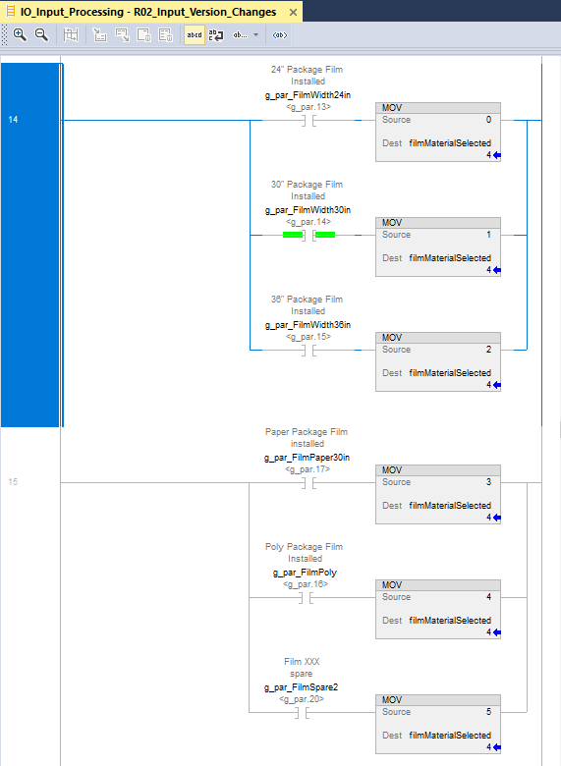

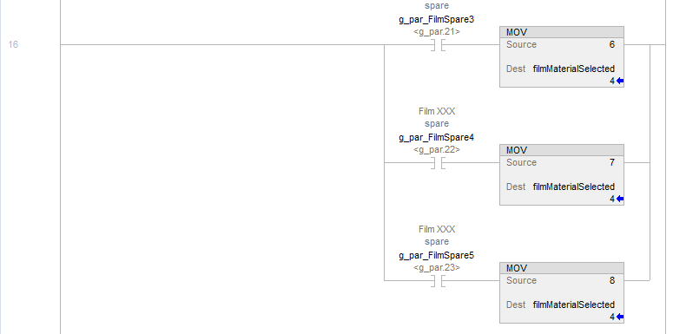

# Kickout “The scanned box barcode is not valid”

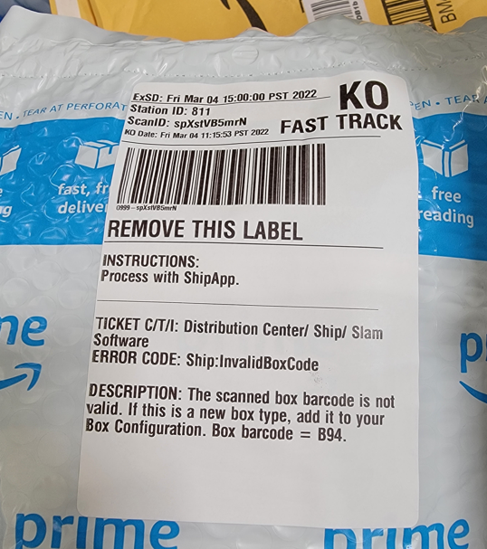

# HMI not showing data after update

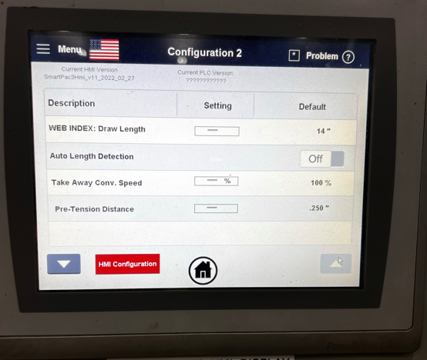

Update HMI firmware

<https://drive.corp.amazon.com/folders/SmartPac/Code%20Repository/02_HMI%20Code/SmartPac%203.x/firmware>

# ASIN Tote Supply conveyor empty and/or Machine Starved warnings on HMI

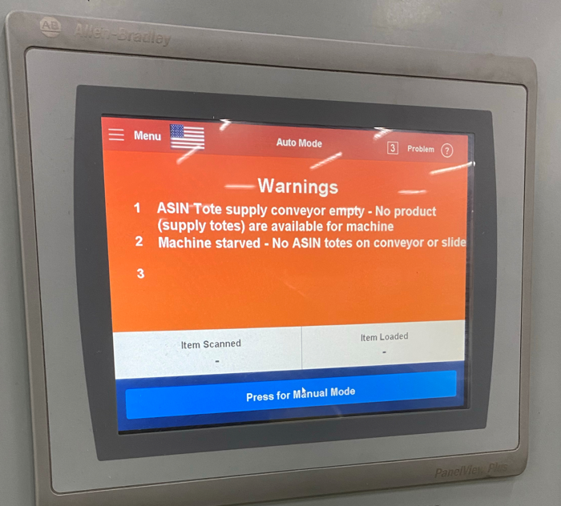

This is likely due to sensors being light activated vs dark activated. gPar.7 and gPar.8 allow inverting the sensor if needed. <https://w.amazon.com/index.php/FCShip/SmartPac#g_Par_Definitions_.28Machine_Option_Settings.29>